Unit 8: Quadratics
Lesson 4 : Solving Quadratics by the Quadratic formula
Objectives:
- I can simplify radicals.
- I can use the quadratic formula to solve quadratics algebraically

Agenda:
- Quiz
- Warm up
- Video
- Practice and application

Focus Questions:
- How can simplify radicals using perfect squares?
- When can we use the quadratic formula to solve quadratics?

Vocabulary:
- Radicals, The Quadratic Formula

Homework: HW 8-3
Web Support:
https://www.khanacademy.org/math/algebra/quadratics/solving-quadratics-using-the-quadratic-formula/v/quadratic-formula-1
https://www.khanacademy.org/math/algebra/quadratics/solving-quadratics-using-the-quadratic-formula/v/quadratic-formula-2

Warm Up: Solve Graphically: Find the axis of symmetry algebraically.

- ${ { x}^{2 }+5x+6=0 2. x}^{2}-6x+9=0$

3) Solve by completing the square for number 2.

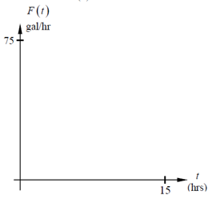
4. The flow of oil in a pipe. In gallons per hour, can be modeled using the function $f\left(t\right)=-2t^{2}+20t+11$ .
(a) Using your calculator, Sketch the function on the axes provided.
(b) Find to the nearest tenth of an hour, the time when the flow stops. Show your work

Notes: Solve algebraically by the quadratic Formula:
where a, b, and c are real numbers in the quadratic standard form

$$1. { { x}^{2 }+5x+6=0 2. x}^{2}-6x+9=0$$

3. $x^{2 }-4x-41=0$ 4. $x^{2}+2x+5=0$

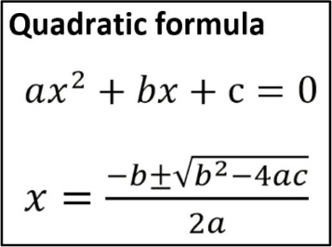
15. ${3x}^{2}+2x-5=0$ 16. $x^{2}-16=0$

17. ${3x}^{2}-4x+1=0$ 18. $x^{2}-7x+4=0$

Name: ___________________ Date: _______________
Homework 8-4: quadratic formula>

1. In the following equation${ 2x}^{2}-3=5x$what are the values of a, b, and c?

2. In the equation$x^{2}=5$ what are the values of a, b, and c?

Simplify the following Radicals:
3. $\sqrt{3^{2}-4(-1)}$ 4. $\sqrt{5^{2}-3(3)}$ 5. $3+\sqrt{4^{2}+5}$

6. $\frac{-3±\sqrt{{(-3)}^{2}-4(2)(-5)}}{2(2)}$ 7. $\frac{-3±\sqrt{{(-3)}^{2}-4\left(1\right)(1)}}{18}$

Solve the following quadratics by the Quadratic formula and check your answers graphically.

8) $x^{2}+8x+15=0$ 9) ${3x}^{2}+5x-2=0$

10) ${12x}^{2}+4x=0$ 11) ${10x}^{2}+2x+6=0$

